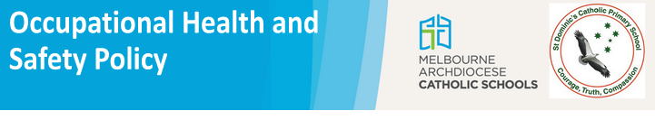
There is a legal requirement for employers to consult with Health and Safety Representatives and employees on health and safety matters that will or are likely to directly affect their health, safety or welfare. Consultation does not have to mean agreement; however, there must be an opportunity for sharing of information, giving employees a reasonable opportunity to express their views and take into account those views.

St Dominic’s Catholic Primary School is a school which operates with the consent of the Catholic Archbishop of Melbourne and is owned, operated and governed by Melbourne Archdiocese Catholic Schools Ltd (MACS).

Aim of this OHS policy
To inform staff, students, visitors, contractors and volunteers that occupational health and safety (OHS) is an integral part of all operations at St Dominic’s Catholic Primary School.

Who has ultimate authority and responsibility for OHS in this school?
The daily administration of OHS matters has been delegated to the school principal Jeffrey Parker.

Commitment to OHS
St Dominic’s Catholic Primary School and its management are committed to:

- providing a safe and healthy workplace to staff, students, visitors, contractors and other parties
- ensuring that our school can meet its OHS obligations
- providing OHS information, training and supervision to employees and other relevant parties
- consulting with employees (and their representatives), managers and other stakeholders on OHS issues
- resolving any OHS issues by following the school’s OHS Issue Resolution procedure.

Responsibilities
St Dominic’s Catholic Primary School and its senior management are responsible for:

- providing adequate resources for implementing this policy, which includes assigning responsibilities for OHS duties
- providing and maintaining safe plant and systems of work
- making and monitoring arrangements for the safe use, handling, storing and transport of plant and substances
- maintaining, so far as is reasonably practicable, a school that is safe and without risks to physical and mental health
- providing adequate facilities for the welfare of all employees and students
- providing information, training and supervision for employees and contractors, enabling them to work in a safe and healthy manner.

Employees, contractors and subcontractors will be responsible for:

- fulfilling their duties under OHS legislation and acting in a safe manner
- taking reasonable care of their own health and safety, and that of others affected by their actions
- complying with the safety procedures and directions
- acting in accordance with agreed school procedures for accident and incident reporting, and reporting potential hazards to the principal or their representative.

Review
St Dominic’s Catholic Primary School is committed to continual improvement of its OHS performance.

Authorised by
principal:
Signature: | Date:

Policy ratified by school leadership team: February 2024

Person responsible: Jeffrey Parker

Next review date: February 2025

Relevant legislation
Victorian Occupational Health and Safety Act 2004

Related school policies
Essential Safety Measures Policy

Related documents
OHS Issue Resolution Flowchart OHS Induction Checklist
First Aid Procedures

External resources
WorkSafe Victoria 2017 OHS in schools: A practical guide for school leaders

