Democratic Principles Statement

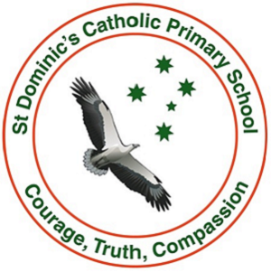

Democratic Principles
At St Dominic’s Catholic Primary School we recognise that the school plays a vital role in advancing democratic ideals and principles. For democracy to continue to thrive, children must be taught democratic ideals and principles and to value its way of life. St Dominic’s Catholic Primary School will explicitly and implicitly support and promote the principles of Australian democracy, including a commitment to:
- elected government
- the rule of law
- equal rights for all before the law
- freedom of religion
- freedom of speech and association
- the values of openness and tolerance.

Through our curricular and extracurricular programs, St Dominic’s Catholic Primary School will prepare our children to become citizens who will preserve and shape democracy in the future. Democratic values will be taught explicitly in the curriculum and implicitly in the child’s experience of the school, from classroom practice, and from what is taught to how it is taught.

Reporting
The Melbourne Archdiocese Catholic Schools (MACS) Board will ensure schools have published this Democratic Principles Statement through the Annual Report to the School Community and regular school review processes (at least once every four years).

